1. Create one vpc in N.virginia region.

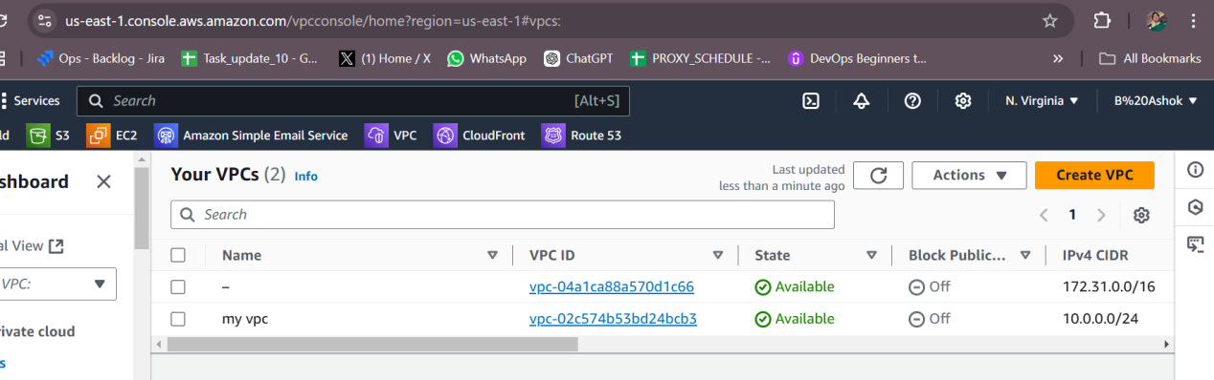

1. Create two subnets. One Public subnet and one private subnet.

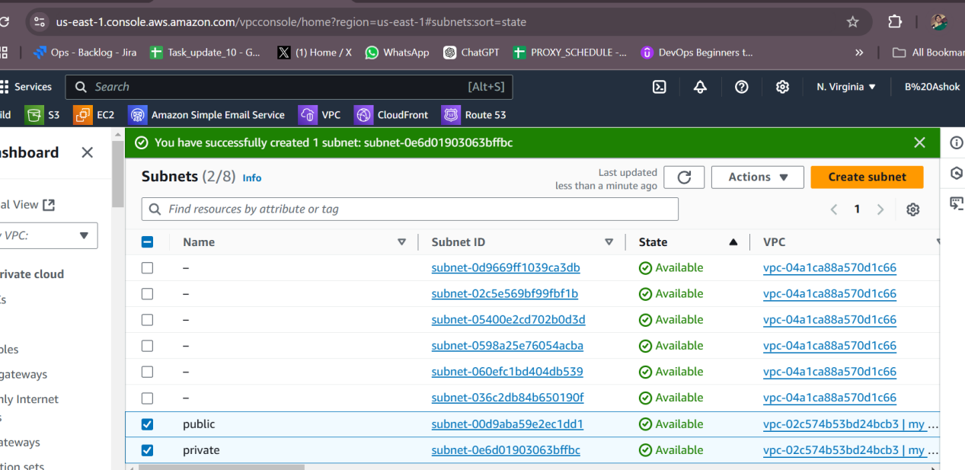

1. Provide the IGW to the vpc.

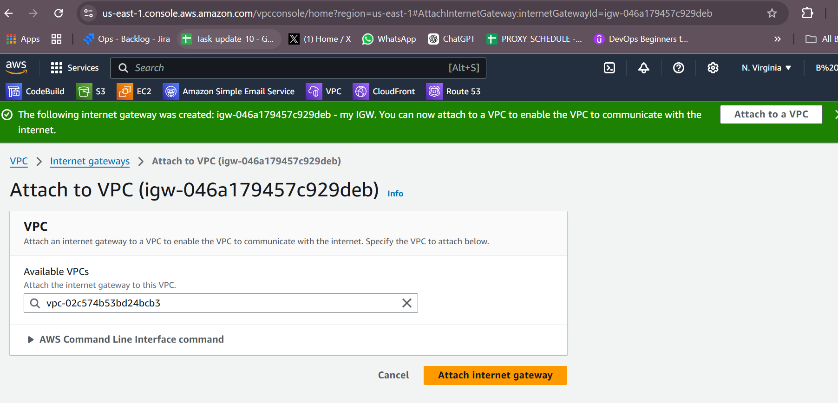

1. Create One public RT and one private RT.

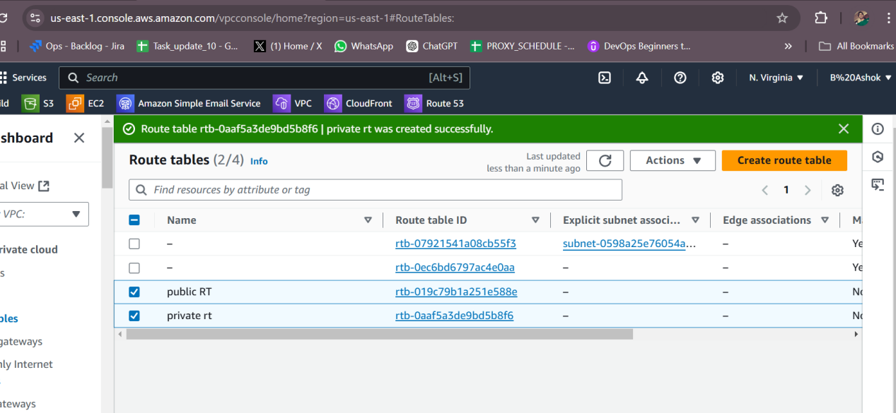

1. Deploy NAT gateway on public subnet and attach the NAT gatewat to private subnet.

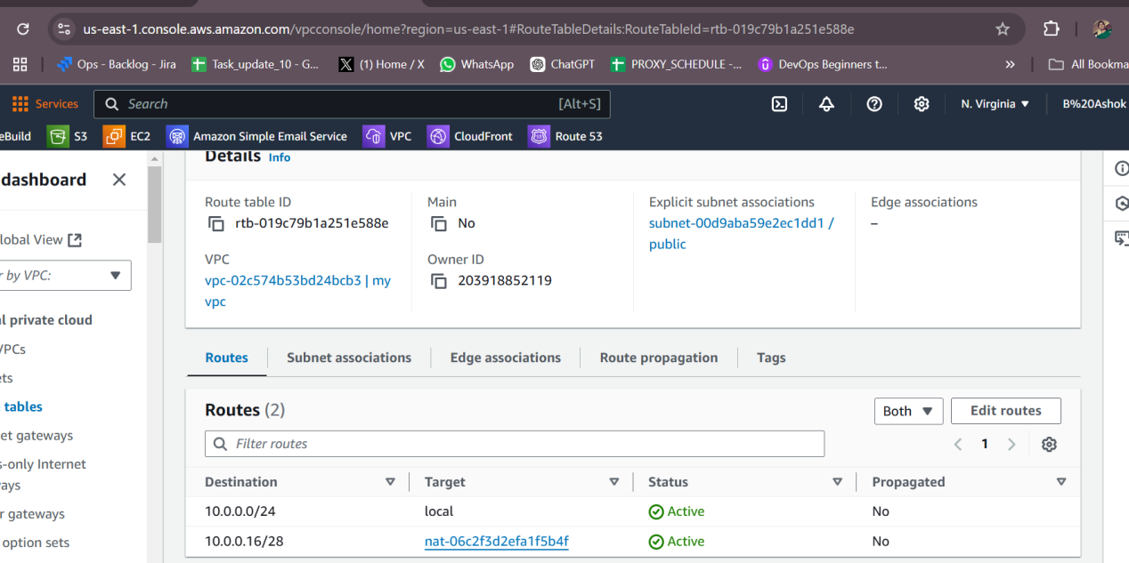

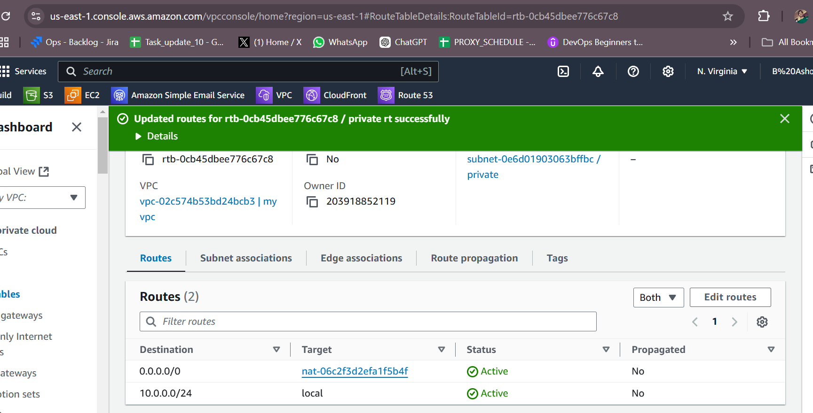

1. Create Two instances,one in public subnet and one in private subnet.

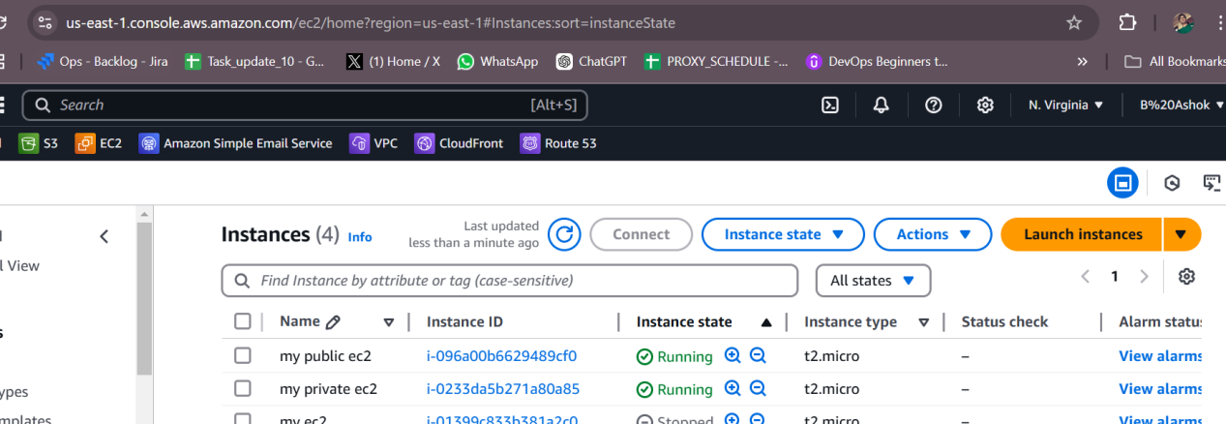

1. Deploy Apache server on both the ec2 instances with sample index.html file.

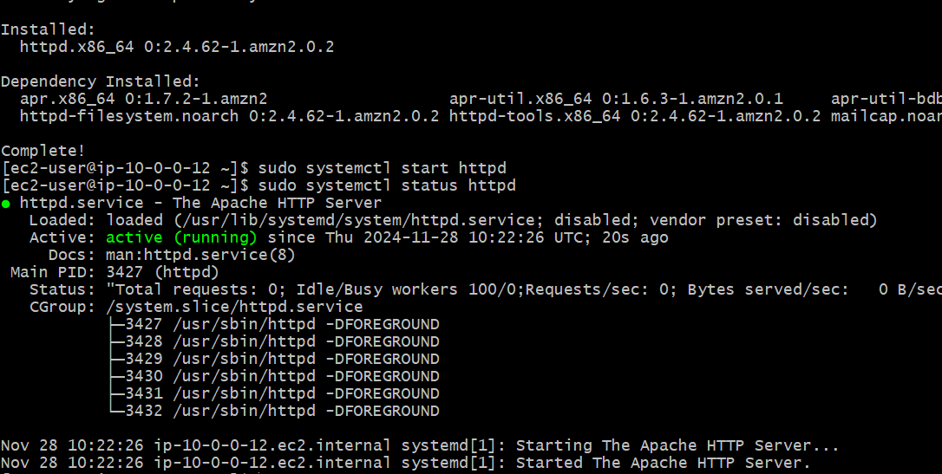

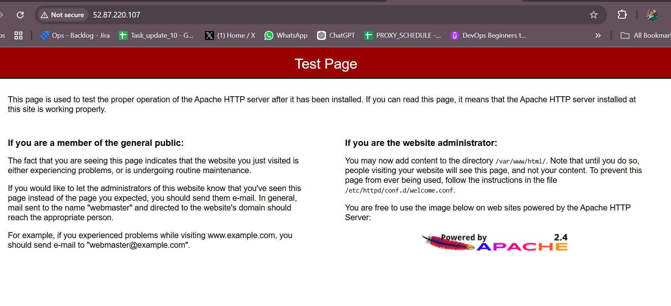

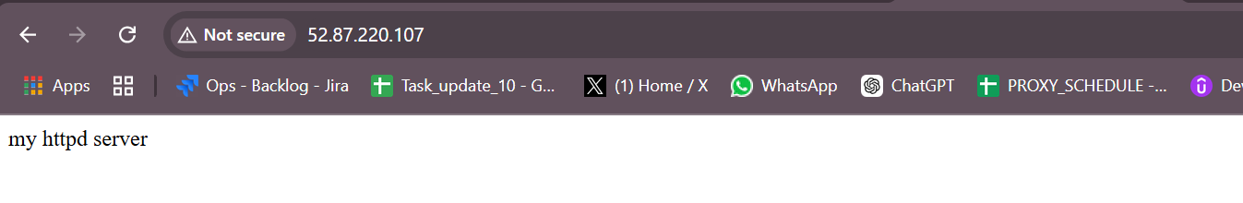

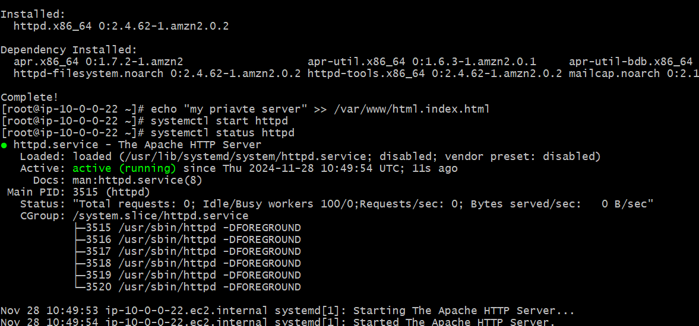

1. Create one application load balancer and attach the load balancer to both the ec2 instances.

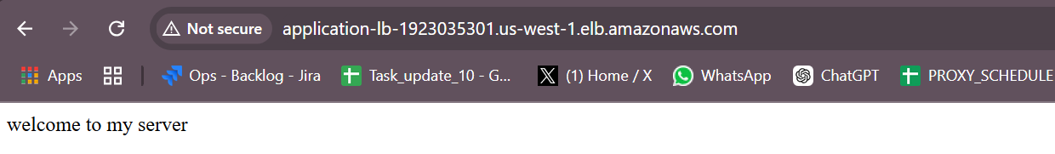

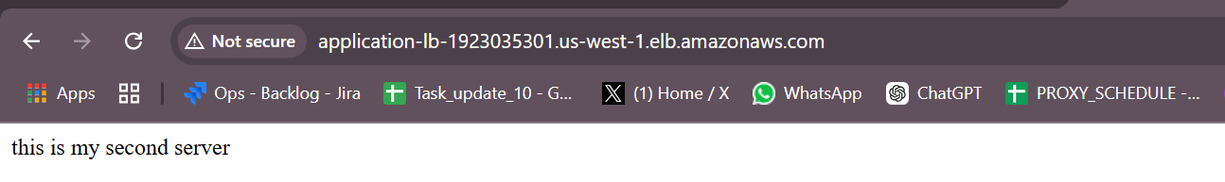

1. Store Application load balancer logs to s3.

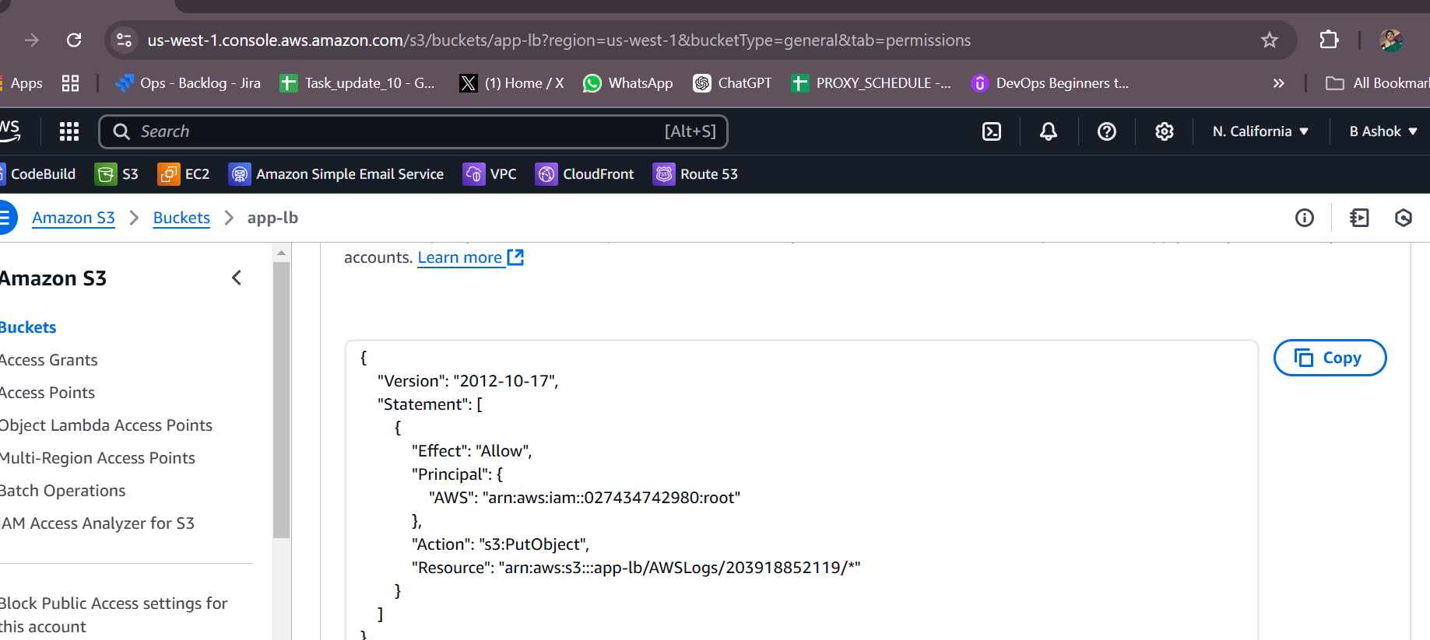

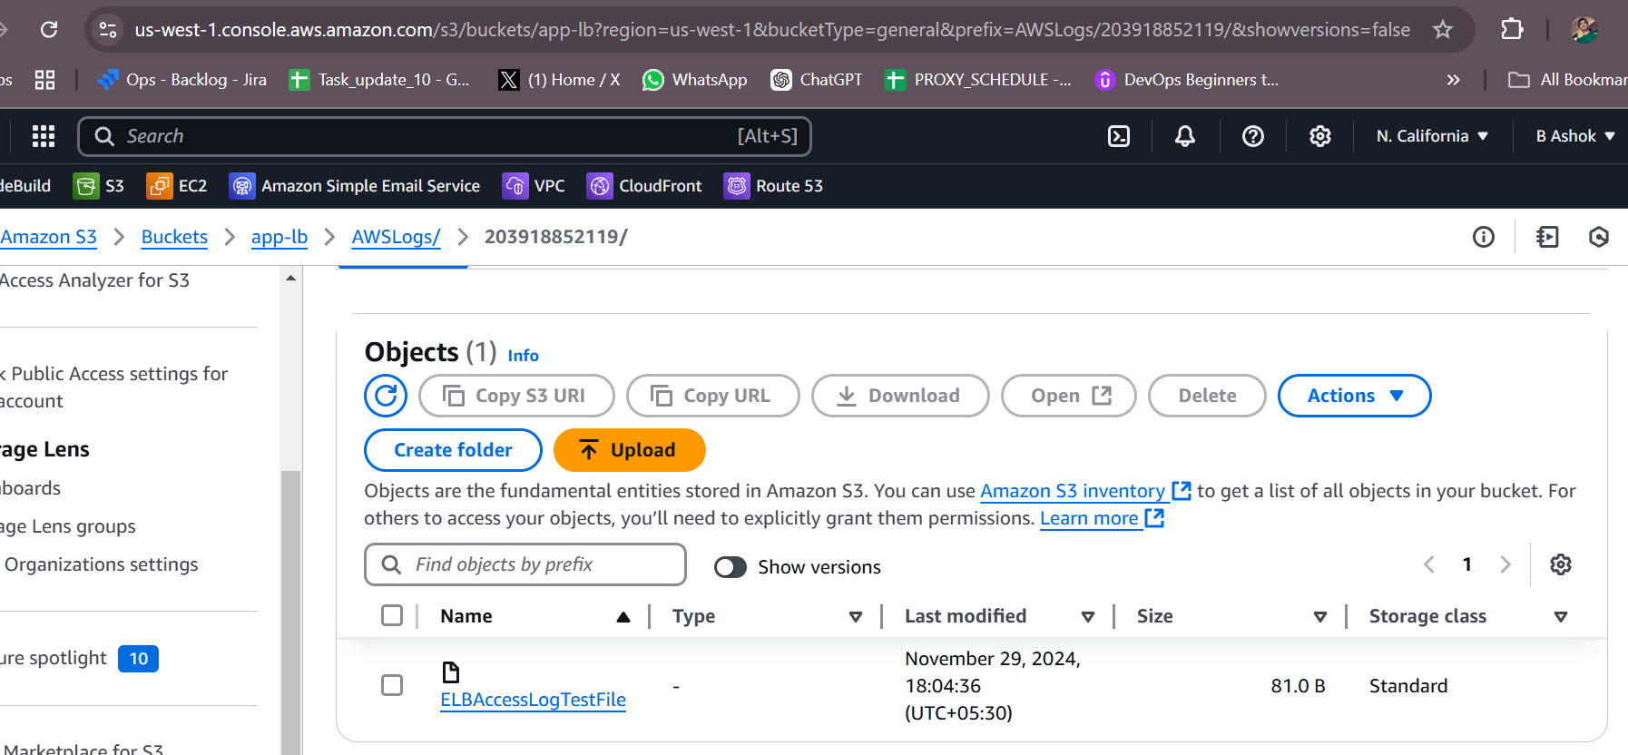

1. Store the vpc flow logs to cloudwtach group.

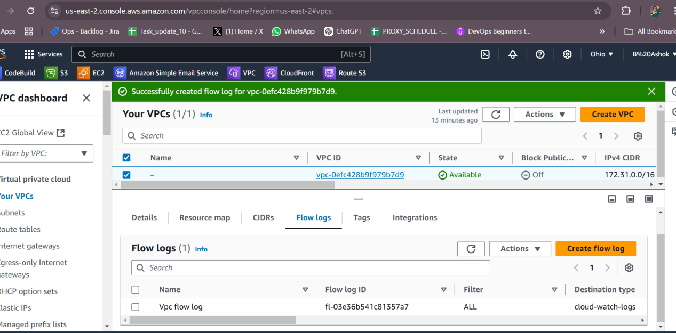

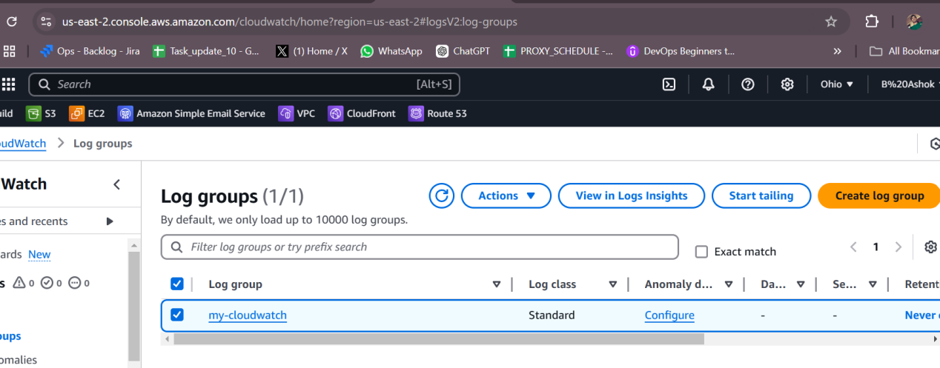

1. Create Monitoring Dashboards to monitor cpu utilization and to monitor apache service.
2. CPU utilizationis more than 50% then it should triggere Autoscaling and launch new instance.

